**DEPLOYMENT**

**Objective 1: Perform business validation of the model**

We test the data set according to the process created in Rapid Miner (See Figure-1) and find the accuracy %95 of our model (See Figure-2,3) by using Performance operator.

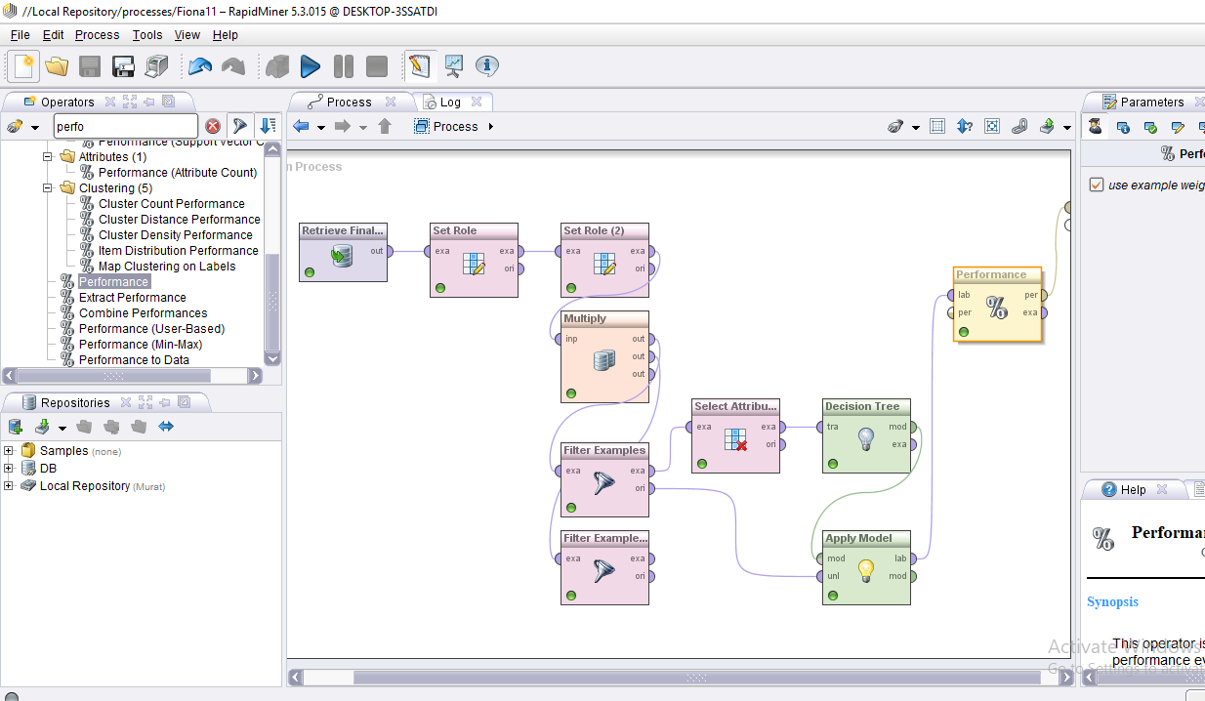

**Figure-1:** The process of testing the model in Rapid Miner.

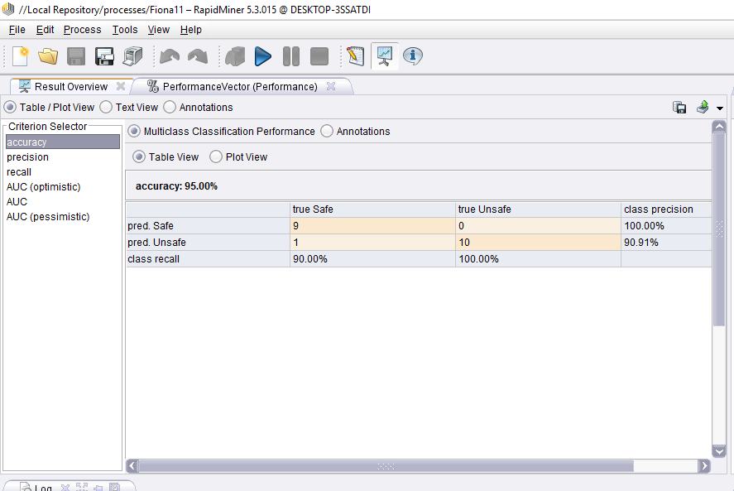

**Figure-2:** The accuracy results of our model in the test phase.

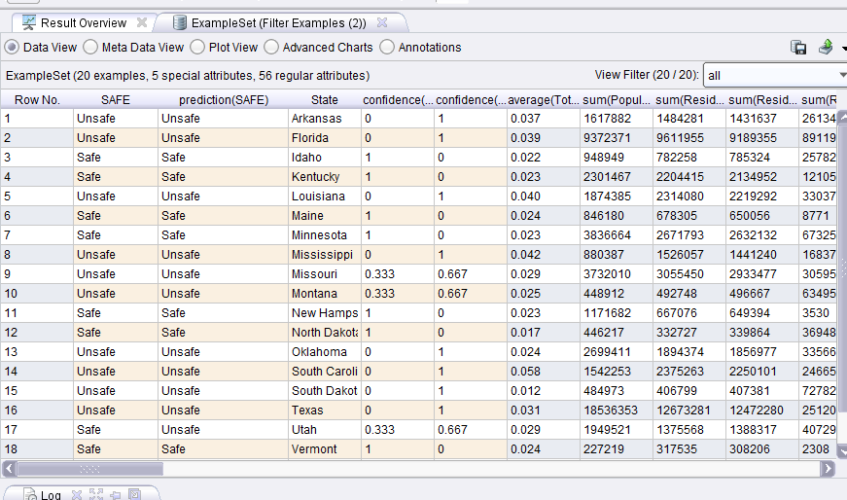

**Figure-3:** The result table of our model in the test phase.

**Objective 2: Produce the report with findings and recommendations for deployment**

According to our data set, we found out the safety level of 30 states in the US. As the factors we determined and the model we built defines our safety level, some of the states are found as safe and some of them are found as unsafe. As seen in Figure-4, the confidence level of being safe and unsafe of a state is set and up to the calculation of these, the prediction score is showed up.

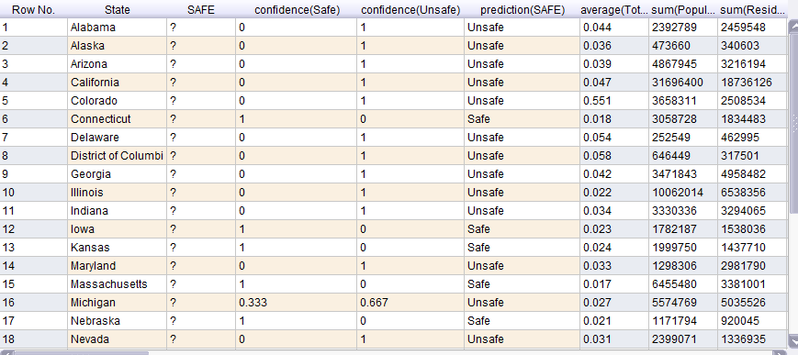

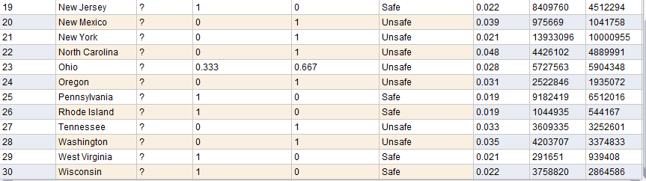

**Figure-4:** The prediction report of the 30 states safety level.

As we change the data set, our model also works. So we build a system for predicting the safety level of one place according to the factors we determined. So in the future it can be tested with bigger data sets and more various factors, so it will give better and more realistic results.